A Report
On
LAMP Stack

By:
Shaurya Agarwal
2021AAPS2047H

At
K2 Cloud Pvt. Ltd.



A Practice School Station of
BIRLA INSTITUTE OF TECHNOLOGY & SCIENCE, PILANI
(July 2023)



A Report
on
LAMP Stack

By
Name of Student | ID Number | Discipline
Shaurya Agarwal | 2021AAPS2047H | B.E Electronics and Communication Engineering

Prepared in the partial fulfillment of the
Practice School-1 Course Number
BITS F221

At
K2 Cloud Pvt. Ltd.
A Practice School Station of
BIRLA INSTITUTE OF TECHNOLOGY & SCIENCE, PILANI
(July 2023)

BIRLA INSTITUTE OF TECHNOLOGY AND SCIENCE, PILANI
(RAJASTHAN)
Practice School Division

Station: K2 Cloud Pvt. Ltd.
Centre: Gurgaon(online) Duration: 50 Days
Date of Start: 30th May
Date of Submission: 9th July
Title of Project: LAMP Stack

Name | ID | Discipline
Shaurya Agarwal | 2021AAPS2047H | B.E. Electronics and Communication Engineering

Name and Designation of the expert: Pooja Kushwaha, DevOps Engineer

Name of PS faculty: Sugata Ghosal

Key Words: LAMP Stack, Linux integration, Shell Scripting, Ubuntu, Virtual Machine, Firewall settings, Docker-Compose, Host Machine

Project Areas:

1. Install and configure VirtualBox with Ubuntu server operating system, create a separate user for docker and then install docker and docker compose.

2. Perform the task of running LAMP stack in docker container, set up a Web-page in a docker container and access the Web-page from the host.

Abstract:

The main objective of this project is to develop a high level of proficiency in working with Linux platforms and shell programming. The project then shifts its focus towards the utilization of LAMP stacks and Docker. When we refer to a "LAMP stack," we are talking about a combination of different software components that are used together to create web applications. These components include the Linux operating system, the Apache web server, the MySQL database, and the PHP programming language.
By leveraging the capabilities of Docker, an open-source platform, developers can package their programs into containers, which enable fast and reliable deployment across diverse environments. This approach ensures that the applications are easily portable and scalable.
The connection between LAMP stacks, Docker, and DevOps becomes apparent when considering the effective and reliable deployment and management of applications. DevOps, a software development methodology, combines development and operations by emphasizing collaboration, automation, and continuous integration and delivery.

Within the scope of this project, the main focus lies in self-education within the DevOps domain. This entails acquiring knowledge and skills related to collaboration, automation, and the seamless integration of development and operations processes. By exploring the possibilities offered by LAMP stacks, Docker, and DevOps, this project aims to enhance proficiency and foster a comprehensive understanding of these technologies and methodologies.



Signature(s) of Student(s) Signature of PS Faculty
Date: 9th July 2023 Date:

ACKNOWLEDGEMENT

I would like to express my sincere appreciation and heartfelt thanks to all those who played a role in the successful completion of this project.
First and foremost, I would like to extend my deepest gratitude to my project mentor, Mrs. Pooja Kushwaha, for her unwavering support and encouragement throughout the "LAMP STACK" project. Her prompt guidance and assistance have greatly influenced the progress and outcome of this endeavor.
I would also like to acknowledge and thank the entire K2 cloud team, including Bajrangi sir, Arul sir, and others, for their valuable advice and mentoring. Their expertise and guidance have been instrumental in shaping the project and enabling me to recognize the immense potential of cloud computing.
I am immensely grateful to BITS Pilani for providing me with this wonderful opportunity. Without their support, this project would not have been possible, and I am truly grateful for the chance to engage in such meaningful work.
Lastly, I would like to express my humble appreciation to everyone who contributed to this project, no matter how big or small their role. Their collective efforts have been crucial to the project's success, and I am truly grateful for their unwavering support and confidence in me.
Once again, I extend my deepest gratitude to each and every individual who played a part in making this project a success. Your contributions and support have been truly invaluable.

TABLE OF CONTENTS

1. Cover Page

2. Title Page

3. Abstract Sheet

4. Acknowledgement

5. Table of Content

6. About the PS

7. Introduction

8. Objectives

9. Project Description

10. Conclusion

11. References

12. Glossary

ABOUT THE PS: K2 CLOUD PVT. LTD.

Gurugram based company, K2 Cloud Pvt. Ltd., is a dynamic and innovative technology company that specializes in cloud computing solutions. They provide services for managing cloud infrastructure, data storage and backup, moving and integrating applications, and cloud security. Customers can shift their technology to the most cutting-edge platforms with the aid of K2 Cloud, which provides a full range of cloud services. They provide clients with unique solutions, producing things that draw attention and leave lasting effects. They give organizations the capacity to optimize operations, boost security, increase scalability, and undergo digital transformation by utilizing cutting-edge technologies. K2 Cloud, a company dedicated to quality, is a dependable resource for Gurgaon-area companies looking for dependable and effective cloud solutions.

Services provided by K2 Cloud:

1. Cloud Management
2. Application Development
3. Cloud Data & Analytics
4. DevOps
5. Cloud Migration
6. Cloud Consulting
7. AI solutions

INTRODUCTION

The project entails the establishment of a LAMP stack through the utilization of Docker containers. This involves configuring virtual machines, installing Docker, running web pages, and setting up firewall rules. The LAMP Stack, an acronym for Linux, Apache, MySQL, and PHP, combines several open-source software components commonly used in web development.
Linux serves as the foundational operating system for the stack, offering stability, security, and a wide range of available distributions.
Apache functions as the web server software, responsible for handling HTTP requests and serving web pages to clients. It is known for its flexibility, reliability, and extensive configuration options.
MySQL serves as the chosen relational database management system (RDBMS) within the LAMP stack, providing efficient storage and management of data. It is widely used, offering features such as data integrity, scalability, and support for multiple programming languages.
PHP, the server-side scripting language, is an integral part of the LAMP stack. Designed specifically for web development, PHP seamlessly integrates with Apache and MySQL, enabling the creation of dynamic websites and web applications.
Collectively, the LAMP stack presents a robust and widely adopted environment for the development and deployment of dynamic web content and applications.

OBJECTIVES

The objectives of this project are as follows:

1. Install and configure a virtual machine using Virtual Box.

2. Update the operating system using the command-line interface (CLI).

3. Create a separate user with restricted privileges for Docker.

4. Install Docker and Docker Compose.

5. Write the Docker Compose configuration for the LAMP stack.

6. Run the LAMP stack within a Docker container.

7. Set up a web page within the Docker container.

8. Configure firewall rules for security.

9. Access the web page from the host system.

Overall, this project demonstrates the deployment of a LAMP stack using Docker containers, emphasizing security, scalability, and accessibility. The utilization of Docker simplifies the management of the stack while ensuring consistency and portability across different environments.

Project Description:

This project involves setting up a LAMP (Linux, Apache, MySQL, PHP) Stack using Docker containers. Here's a step-by-step explanation of each task:

1. Install VirtualBox:

It is the software which helps us run Virtual Machines inside your computer. A Virtual Machine is the virtualization or emulation of a computer system. Virtual machines are based on computer architectures and provide the functionality of a physical computer.

We can install VirtualBox by going to their website.

2. Install Vagrant:

Vagrant is a command line utility for managing the life-cycle of virtual machines. It isolates dependencies and their configuration within a single disposable and consistent environment. This software is important as it helps us to direct ports from our physical system to the virtual machine.

To install vagrant, you need to follow the steps listed on the website whose link will be provided in the references section. But for the sake of convenience, I will show you how it is done.

Step1: We install vagrant from the website.

Step2: Initialize a project directory. For myself, I named my directory Vagrant just to keep it simple

Step3: Enter the project directory inside the command line and then type the following command:

vagrant init hashicorp/bionic64

This command will install Ubuntu 18.04 LTS into your Virtual Machine.

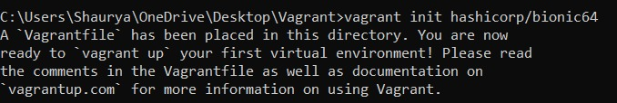
Step4 (IMPORTANT): Once you have installed Ubuntu on your virtual machine, you will find a VagrantFile inside your project directory. We need to make changes in that so we can run our LAMP Stack inside our Virtual Machine and get the Web-page in our host machine. The way we do that is by using something called port-forwarding. What it does is, it redirects the ports from our host machine to the Virtual Machine. To do this, we need to find the line inside our VagrantFile which has “port-forwarding” in it. Then, we need to uncomment that line by removing the “#” symbol and forward the port 80 of the host machine to port 80 of the virtual machine. Port 80 corresponds to HTTP so when we forward port 80, any http request coming from the host machine will get received by the Virtual Machine and vice-versa. We also need to forward the port 8001 to access phpmyadmin. It would look something like this inside the VagrantFile:

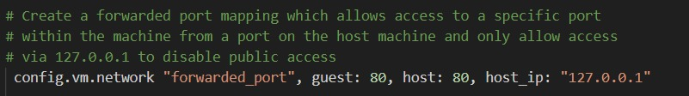
3. Access Virtual Machine:

Once Vagrant is installed on your system, we need to open command prompt on our windows system and go to the directory where our VagrantFile is. Once there, we need to run the following commands:
vagrant up
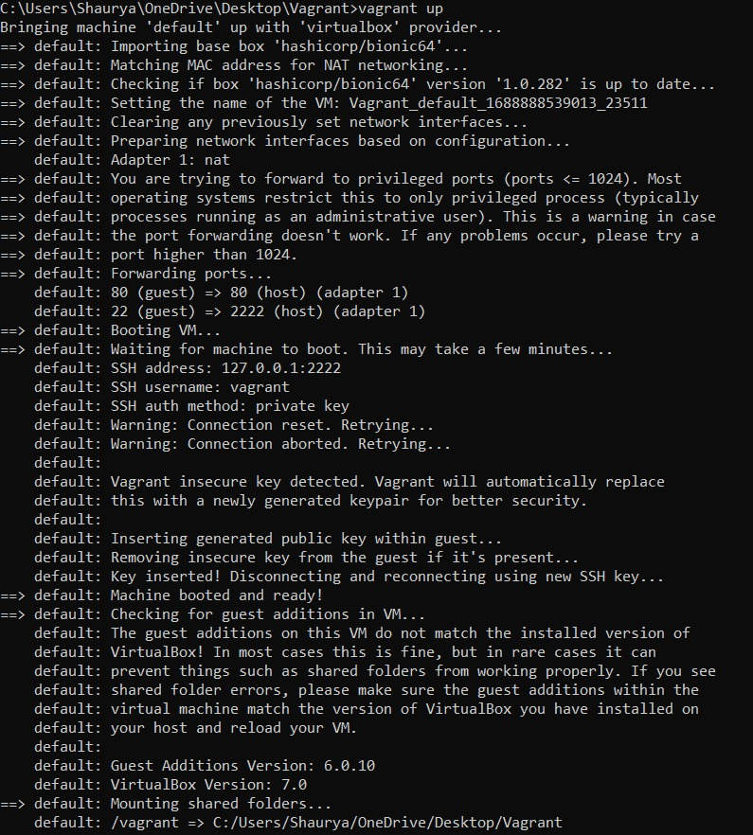
vagrant ssh

After running both of them one after the other, we will have access to the command line of the Linux operating system.

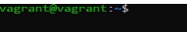

Once in, update the Operating system using the following command:
sudo apt update

4. Install Docker and Docker Compose:

Docker is a containerization platform that allows you to run applications in isolated environments called containers.

To install Docker on your Linux machine(in this case I used Ubuntu) run the following command:
sudo apt install docker.io

Similarly, to install Docker Compose, we run this command:
sudo apt install docker-compose

5. Make directory for making LAMP Stack and make the docker-compose file:

Make a directory for the LAMP Stack by using the following command:
mkdir lamp-docker

Once done, enter the directory we just made using:

cd lamp-docker

We now make a docker-compose file using the following command:

touch docker-compose.yml

P.S: I personally made the “lamp-docker” directory in the “/vagrant” directory of the Virtual Machine. This is because the “/vagrant” directory in our Virtual Machine is synced to the Vagrant directory we made on our Windows machine. So we can sync files between Windows and our Virtual Machine. Also, if we have uploaded our code to GitHub, we can easily update the code through GitHub desktop even if we have made changes in the code in our Virtual Machine.

Docker Compose uses a “YAML” file to define the configuration for your containers. You need to write a Docker-Compose file that specifies the services required for your LAMP stack, which includes Apache, MySQL, and PHP.

To edit the docker-compose file, we use this command:

nano docker-compose.yml

Nano is a text editor which works on the command-line. If you don’t like to use nano, you can always use other command-line based text editors like Emacs or Vim

To save changes to the file that you have made, you use:
Cntrl+O then Cntrl+X

P.S: I have uploaded my entire LAMP Stack directory on GitHub. I will be sharing the link to my repository with you here:

https://github.com/APUNJIA/lamp-docker

I will also share a screenshot of my docker-compose file on the next page.

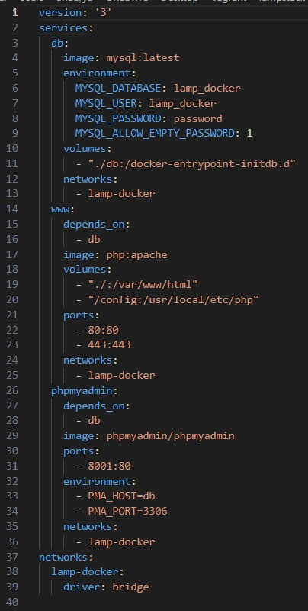

(Docker-Compose File)
6. Accessing phpmyadmin:

Before running the actual website, we need to add some data in our database so that the index.php file can output the same in the Web-Page.

This is where phpmyadmin comes in. We enter phpmyadmin by going to port 8001 of the address 127.0.0.1

After running that, we will get to the homepage:

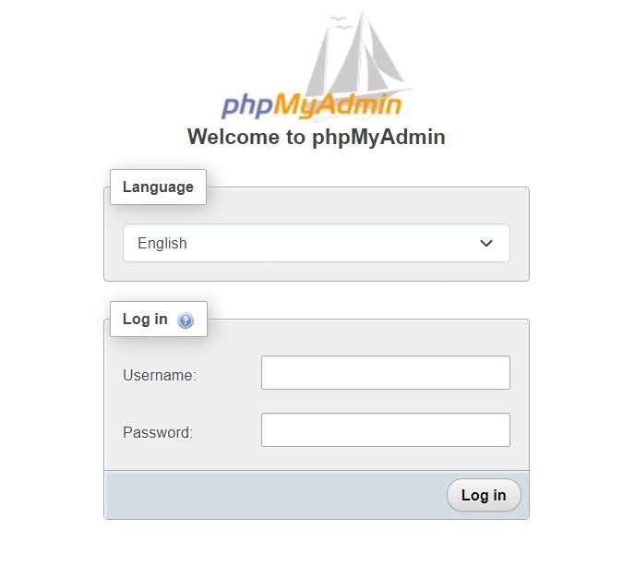
I have set my username as “lamp_docker” and password as “password” (See lines 6-8 in my Docker-Compose file). Once I enter the details, we can now make our database by inserting a table. My table looks something like this:

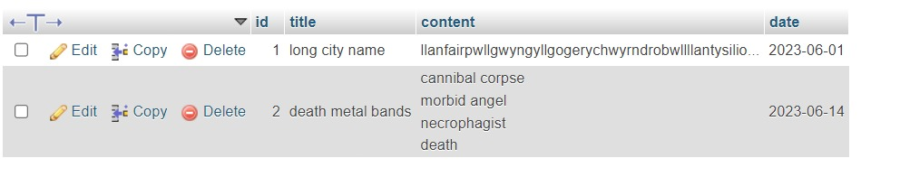
Once we run the website, we will see the details of this table on the Web-Page. This is because of the index.php file I made which is in the same directory as my docker-compose file. I have also made a sub-directory called “db” which stores the .sql file of the database. I have named that file “dump.sql”. I also have a “phpinfo.php” file which honestly serves no purpose other than giving information about what version of php I’m using and it tells me what version of Apache is compatible with this current php version. You can access this information when you type phpinfo in your browser once the LAMP Stack is up and running.

I’ll also share the screenshot of my index.php and the phpinfo.php file on the next page for your convenience:

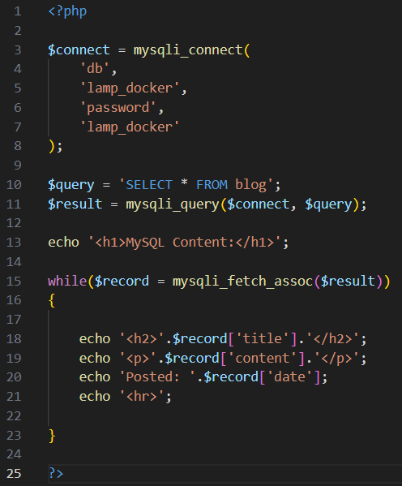

(index.php file)

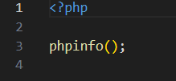

(phpinfo.php file)

7. Run the docker configuration inside the virtual machine:

Once we have made the docker-compose file, and we have made our table, we can run the docker configuration. While in the directory where we made our docker-compose file, we run the following command:

sudo docker-compose up

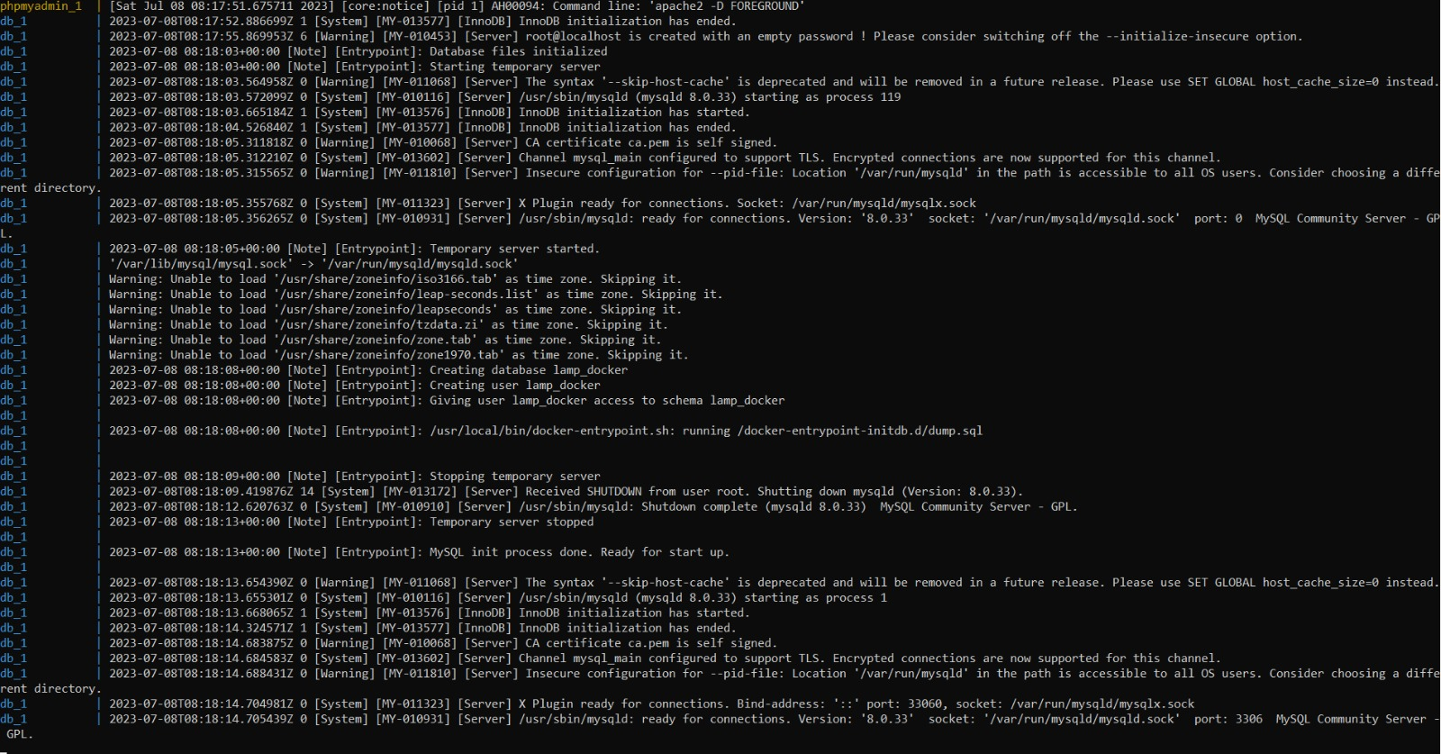
Once the docker configuration is up and running, we can access the web-page from our Windows machine when we type 127.0.0.1 onto our browser.

I got this output:

I discussed this issue with my project mentor during my mid-semester report. However, I was able to successfully resolve the issue subsequently.

8. Post-midsem repairs:

The way we fix this issue is by going inside the docker container which is running our Apache server and enable mysqli commands in there.

Since the docker container has a Linux based architecture, we can use simple bash commands to download and add a bunch of stuff.

To enter the docker container, we first have to open another command-line and enter the vagrant Virtual Machine when the docker containers are still running. We then go to the directory where we have our docker compose file and type the following command:

sudo docker ps

This command will show us what all containers are running in docker. The list would look something like this:

Then we run the following command:

sudo docker exec -it <container_name_or_id> /bin/bash

This command means that we want to execute(exec) the container in an interactive manner(-it) and we want to go to the bash or the terminal of the container(/bin/bash). In the angle brackets in the command above, we need to add either the name of the container or it’s ID.

Once we run the command, we should be inside the container and have access to its terminal.
Then we run the commands:

apt-get update

apt-get install nano

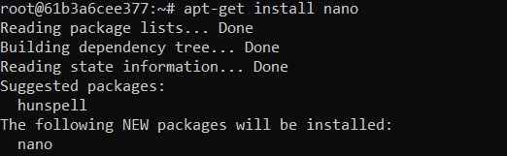
Once done, we run this command to see if the mysqli extension is enabled or not:

php -m | grep mysqli

If this command outputs mysqli, then we have mysqli extension enabled inside our docker container.

If it returns nothing, we can install mysqli by running this command:

docker-php-ext-install mysqli

After the installation, we can run the previous command again and then it will output mysqli meaning the extension is installed.

If it shows the following error:

We can simply fix it by creating the directory in the respective location. We can do this by:

mkdir /usr/local/etc/php/conf.d

Once we make the directory, we run the mysqli command again and it should install with no problem.

We can then check the installation by running the command:

php -m | grep mysqli

And it should output mysqli like in the following image:

We then need to make a new directory inside the container by the name of config. We do that by:

cd /

mkdir config

This is important because in our docker-compose file, we have linked the config directory to the php directory. (See line 20 of the docker-compose file)
Then, we need to edit the php.ini file inside the docker container. We can find the location of this file by running the following command:
php --ini

It should give you an output like so:

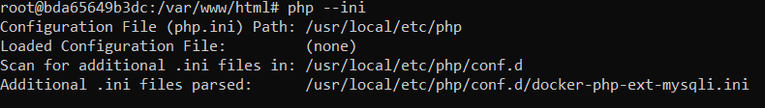
For me, it is in this location:

/usr/local/etc/php

Inside this directory, I found two php.ini files namely:

1. php.ini-development
2. php.ini-production

Of these two, we need to make our edits in the development file as the production file is optimized for production environments with stricter security and performance settings.

If you have a case where there are no files in this directory, we can simply make those files ourselves using nano. We first type this command to create the file and enter into nano to make edits in the file:

nano php.ini-development

And then we copy the code from this github page into our php.ini-development file: https://github.com/php/php-src/blob/master/php.ini-development

We can then we do the same for the production file by copying the code from this github page: https://github.com/php/php-src/blob/master/php.ini-production
After doing so, we have an output which looks like the one in the previous picture.

We then copy the development file from this directory to the “/config” directory by running this command:

cp /usr/local/etc/php/php.ini-development /config/php.ini

This command not only copies the file to the other directory but renames it to “php.ini” as well.

Then we open our php.ini file inside nano and then we un-comment the 2nd line:
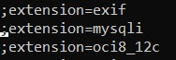

By removing the semicolon at the beginning and then save the file. It should look something like this:

Then we exit the container by typing exit in the bash and then we restart the container for the changes to take effect. For this we run this command:

sudo docker restart <container_name_or_id>

Once done, we go back to our Web-Page and type 127.0.0.1 we get the desired result:

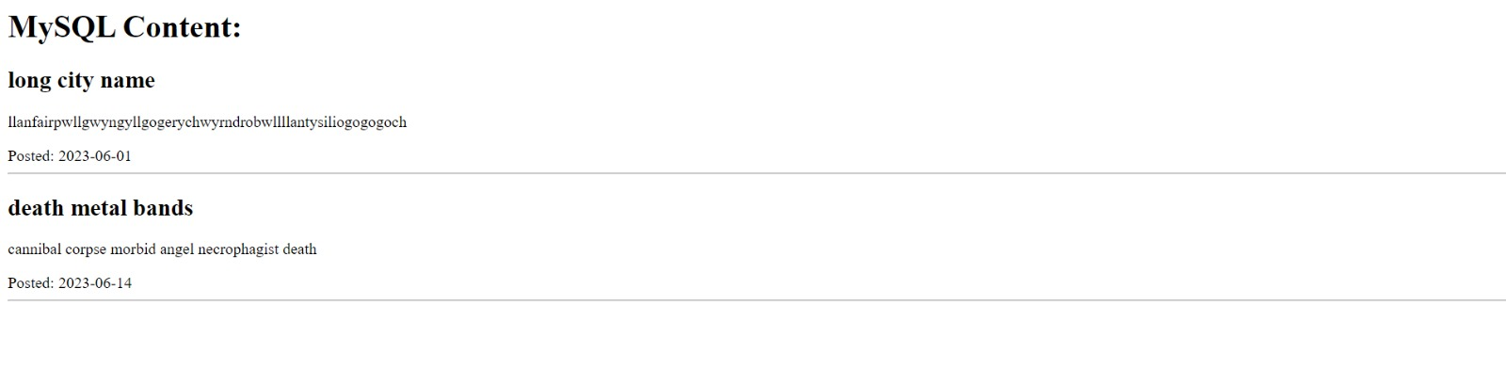
9. Firewall settings:

We also need to update firewall settings in our LAMP Stack. We do it by a tool called UFW. UFW stands for Uncomplicated Firewall which as the name suggests, is pretty easy to get around and use. This tool comes pre-installed in all Linux distributions so there is no need to install it separately.

The way it works is simple, you have the control over what all ports the Virtual Machine can access with one simple command. This ensures that no other data from other ports is coming inside the Virtual Machine when we are running our LAMP Stack.

First we check the status of UFW by this command:

sudo ufw status

If it is not enabled, it should give out this output:

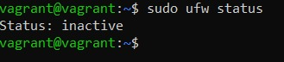

Now, what we need to do is allow ports 80 and 443 respectively. Port 80 corresponds to HTTP and Port 443 is a virtual point through which data transmissions are sent and received. We need these two ports to be active and enabled if we are working with our LAMP Stack.

We enable these two ports by the following command:

sudo ufw allow <port_number>

Once we have done this, we enable UFW by this command:

sudo ufw enable

The output of this command would look something like this:

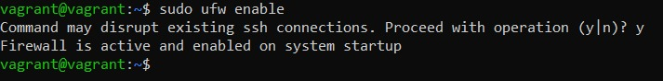
10. Wrapping up:

Once we are done with the website, we can go back to the terminal and cancel the process by:
Cntrl+C

Then we can stop the docker configuration by running the following command:
sudo docker-compose down

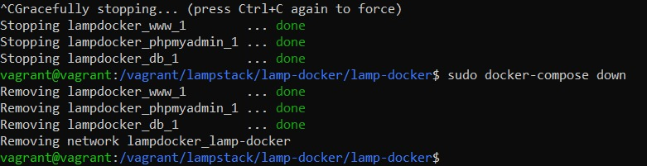
We can then exit the Virtual Machine by typing exit and then typing the following command:

vagrant halt
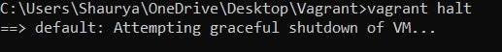

Conclusion:
The successful completion of this project involved the implementation of the LAMP stack using Docker containers, resulting in the establishment of a highly scalable and adaptable environment tailored for web development. By utilizing VirtualBox, Docker, and Docker Compose, we achieved seamless communication, simplified deployment processes, and effective isolation of components within the system.
To ensure the stability and security of the environment, we diligently performed routine updates on the operating system and enforced strict user rights management. Additionally, we employed firewall rules to provide secure access to the hosted web page, prioritizing the safeguarding of sensitive information.
Overall, this project exemplified the remarkable potential of contemporary technology by exemplifying how a containerized LAMP stack can serve as a reliable and efficient platform for the development and deployment of web applications.

Resources:

https://www.virtualbox.org/wiki/Downloads

https://ubuntu.com/download/desktop

https://aws.amazon.com/what-is/lamp-stack/

https://www.digitalocean.com/community/tutorials/how-to-install-and-use-
docker-compose-on-ubuntu-22-04

https://www.youtube.com/watch?v=HG6yIjZapSA&t=31s

https://www.unixmen.com/deploy-lamp-andor-lemp-stacks-easily-using-
docker/

https://linuxjourney.com/

https://www.digitalocean.com/community/tutorials/how-to-install-the-
apache-web-server-on-ubuntu-22-04

https://www.digitalocean.com/community/tutorials/how-to-set-up-a-firewall-
with-ufw-on-ubuntu-22-04

https://github.com/php/php-src/blob/master/php.ini-production

https://github.com/php/php-src/blob/master/php.ini-development

Glossary:
VirtualBox: An open-source virtualization software that allows the creation and management of virtual machines.

Virtual Machine: A virtual emulation of a physical computer system, allowing the installation and operation of multiple operating systems simultaneously.

CLI: Command Line Interface, a text-based interface used to interact with the operating system by entering commands.

Docker: An open-source containerization platform that allows the creation and management of lightweight, isolated software containers.

Docker-Compose: A tool for defining and running multi-container Docker applications using a YAML configuration file.

Host Machine: The physical computer on which the virtual machine and Docker containers are running.

Non-root User: A user account with restricted privileges, typically used for security reasons to prevent unauthorized access or system modifications.

Shell Scripting: The process of creating and executing a series of commands in a shell environment to automate tasks or perform system administration.

Firewall Rules: Configuration settings that control network traffic by permitting or blocking specific connections based on defined criteria, such as IP addresses, ports, or protocols.

